## PROJECT REPORT

Emerging Methods for Early Detection of Forest Fires

SUBMITED BY :

**TEAM ID : IBM-Project-29170-1660121813**

| Yashwanth P | 310619104168 |
| --- | --- |
| Parthiban M | 310619104312 |
| Syed Aakif Zaid | 310619104149 |
| Syed Adnaan I | 310619104150 |

**TABLE OF CONTENTS**

1. **INTRODUCTION**
   1. PROJECT OVERVIEW
   2. PURPOSE
2. **LITERATURE SURVEY**
   1. EXISTING PROBLEM

` 2.2 REFERENCES

2.3 PROBLEM STATEMENT DEFINITION

1. **IDEATION AND PROPOSED SOLUTION**
   1. EMPATHY MAP CANVAS
   2. IDEATION & BRAINSTORMING
   3. PROPOSED SOLUTION
   4. PROBLEM SOLUTION FIT
2. **REQUIREMENT ANALYSIS**
   1. FUNCTIONAL REQUIREMENTS
   2. NON FUNCTIONAL REQUIREMENTS
3. **PROJECT DESIGN**
   1. DATA FLOW DIAGRAM
   2. SOLUTION & TECHNICAL ARCHITECTURE
   3. USER STORIES
4. **PROJECT PLANNING AND SCHEDULING**
   1. SPRINT PLANNING AND ESTIMATION
   2. SPRINT DELIVERY SCHEDULE
5. **CODING & SOLUTIONING**
6. **TESTING**
   1. TEST CASES
   2. USER ACCEPTANCE TESTING
      1. DEFECT ANALYSIS
      2. TEST CASE ANALYSIS
7. **RESULTS**
   1. PERFORMANCE METRICS
8. **ADVANTAGES & DISADVANTAGES** ADVANTAGES DISADVANTAGES
9. **CONCLUSION**
10. **FUTURE SCOPE APPENDIX**

SOURCE CODE GITHUB PROJECT DEMO

# CHAPTER 1 INTRODUCTION

### PROJECT OVERVIEW

Machine learning and deep learning play an important role in computer technology and artificial intelligence. With the use of deep learning and machine learning, human effort can be reduced in recognizing, learning, predictions and in many more areas.

Forest fire detection is the ability of computer systems to recognize Fire from various region of forest , such as fire, smoke, and so on. This

project aims to let users take advantage of machine learning to reduce manual tasks in Detecting the forest fire.

### PURPOSE

The main aim of our project is detection and monitoring the forest fire

To minimize the effect of fire breakout by controlling in its early stage also to protect Domestic by informing about the breakout to the respective forest department as early as possible . We have implemented the IOT technology to achieve our objective.

# CHAPTER 2 LITERATURE SURVEY

### EXISTING PROBLEM

Some of the relevant literary works in this field are briefed below:

The one fourth area of Karnataka is covered by forest, the forest and bio-diversity

of the India are at the considerable chance and beneath enormous pressure. General causes of forest fire are extreme hot and aired weather, lightning and human carelessness. In order to protect these huge stretches of forest land, there need

to be taken early caution measures to control of spreading fire

### REFERENCES

* + 1. [**A Review on Early Forest Fire Detection Systems Using Optical Remote Sensing**](https://www.semanticscholar.org/paper/A-Review-on-Early-Forest-Fire-Detection-Systems-Barmpoutis-Papaioannou/18e8eb6860fdedc651f22f80cc7e0dea10997c23)
       - [P. Barmpoutis,](https://www.semanticscholar.org/author/P.-Barmpoutis/1719084) [P. Papaioannou,](https://www.semanticscholar.org/author/P.-Papaioannou/48904562) [K. Dimitropoulos,](https://www.semanticscholar.org/author/K.-Dimitropoulos/2296506) [N. Grammalidis](https://www.semanticscholar.org/author/N.-Grammalidis/48603481)
       - Environmental Science
       - Sensors
       - 2020

An overview of the optical remote sensing technologies used in early fire warning systems is presented and an extensive survey on both flame and smoke detection algorithms employed by each technology is provided.

* + 1. [Forest Fire Detection System using LoRa Technology](https://www.semanticscholar.org/paper/Forest-Fire-Detection-System-using-LoRa-Technology-Gaitan-Hojbota/3a812ed6ae73e511a53e1b0da17418cf38e736d0)
       - [N. Gaitan, Paula Hojbota](https://www.semanticscholar.org/author/N.-Gaitan/9334012)
       - Environmental Science
       - 2020

This paper proposes a system capable of quickly detecting forest fires on long wide distance using LoRa (Long Range) technology based on LoRaWAN ( Long Range Wide Area Network) protocol which is capable to connect low power devices distributed

on large geographical areas.

* + 1. [**Low Cost LoRa based Network for Forest Fire Detection**](https://www.semanticscholar.org/paper/Low-Cost-LoRa-based-Network-for-Forest-Fire-Vega-Rodr%C3%ADguez-Sendra/08096b9b0d594bc47ae79e9bae568f6aa65d15a9)
       - [Roberto Vega-Rodríguez,](https://www.semanticscholar.org/author/Roberto-Vega-Rodr%C3%ADguez/1471438551) [Sandra Sendra,](https://www.semanticscholar.org/author/Sandra-Sendra/1718316) [Jaime Lloret,](https://www.semanticscholar.org/author/Jaime-Lloret/144484046) [Pablo Romero-Díaz,](https://www.semanticscholar.org/author/Pablo-Romero-D%C3%ADaz/1410576217) [José Luis García-](https://www.semanticscholar.org/author/Jos%C3%A9-Luis-Garc%C3%ADa-Navas/1413064390) [Navas](https://www.semanticscholar.org/author/Jos%C3%A9-Luis-Garc%C3%ADa-Navas/1413064390)
       - Computer Science, Environmental Science

2019 Sixth International Conference on Internet of Things: Systems, Management and Security (IOTSMS)

* + - * 2019

A low cost Long Range (LoRa) based network able to evaluate level of fire risk and the presence of a forest fire and the evaluation algorithm is based on the 3030-30 rule.

* + 1. [**A Survey of Machine Learning Algorithms Based Forest Fires Prediction and Detection Systems**](https://www.semanticscholar.org/paper/A-Survey-of-Machine-Learning-Algorithms-Based-Fires-Abid/c65bacaca70f5bb5ba141b9514b25d3a31848731)
       - [F. Abid](https://www.semanticscholar.org/author/F.-Abid/4583802)
       - Environmental Science, Computer Science
       - Fire Technology
       - 2020

A comprehensive survey of the machine learning algorithms based forest fires prediction and detection systems is presented, highlighting the main issues and outcomes within each study.

### PROBLEM STATEMENT DEFINITION

Some people know about the current issues are the most important ones because it is mostly a lot in the news but sometimes other big issues that change our lives are not mentioned in the news because they are issues that can hurt us in the long run or not really important for the modern public. One issue

I can tell you about is the forest fires. Sometimes people don 't notice or now about the forest fires until it is talk in the news and it 's mostly because it has done a great damage

**CHAPTER 3**

**IDEATION AND PROPOSED SOLUTION**

### EMPATHY MAP CANVAS

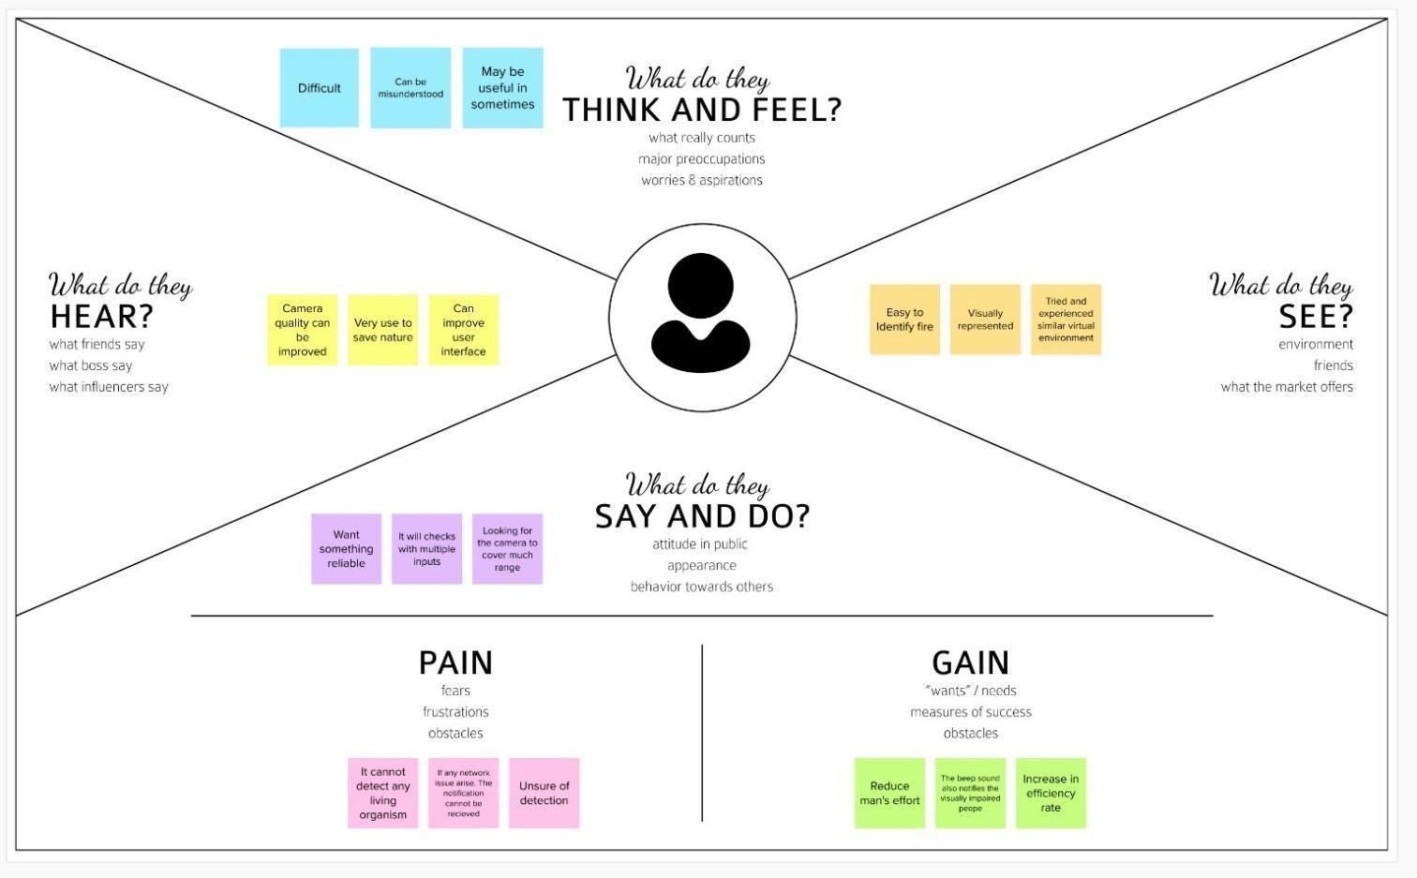

* 1. **IDEATION & BRAINSTORMING**

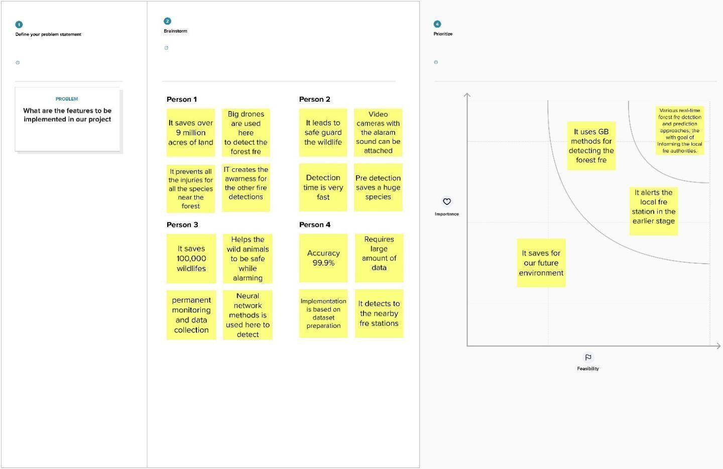

### PROPOSED SOLUTION

| S.No. | Parameter | Description |
| --- | --- | --- |
| 1. | Problem Statement (Problem to be solved) | To find emerging methods for early detection of forest fires using artificial intelligence. |
| 2. | Idea / Solution description | In case of forest fire detection the burning substances are primarily identified as sceptical flame regions using a division strategy to expel the non-fire structures and results are verified by a deep learning model. |
| 3. | Novelty / Uniqueness | Accurate and reliable recognition of sceptical flame regions by means of using YOLO v3 algorithm. |
| 4. | Social Impact / Customer Satisfaction | 1. By using this method we can save environmental damage and lives of living beings. 2. It is fast and accurate method to detect the fire easily and give an alert to the forest fire department simultaneously when the fire is detected. |
| 5. | Business Model (Revenue Model) | The software platform to provide the fully autonomous processing of data received from the camera of UAV to obtain live feed in web App. |
| 6. | Scalability of the Solution | It is mainly developed for detecting the forest fire across the world and useful in surveillance the different sections of the forest. |

* 1. **PROBLEM SOLUTION FIT**

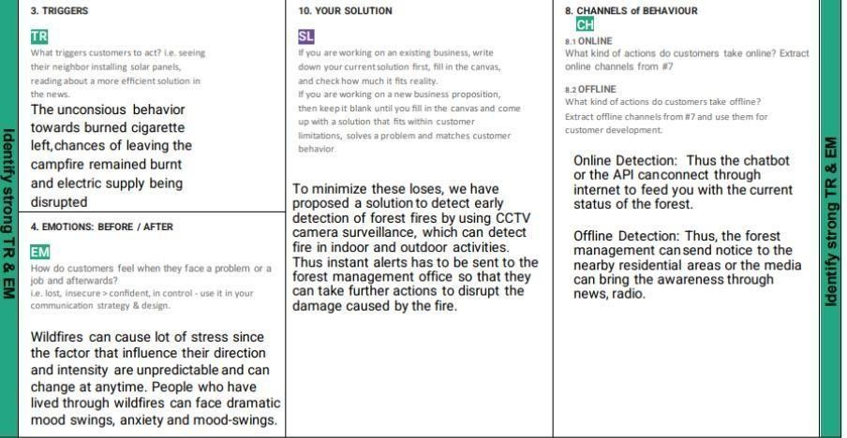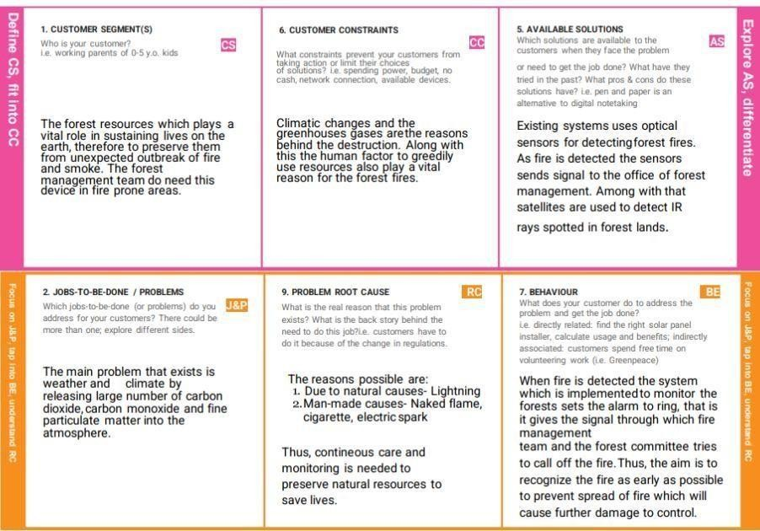

## CHAPTER 4 REQUIREMENT ANALYSIS

### 4.1 FUNCTIONAL REQUIREMENTS

FUNCTIONALREQUIREMENTS:

-Following are the functional requirements of the proposed solution

| **Sn. No** | **Functional Requirement (Epic)** | **Sub Requirement (Story / Sub-Task)** |
| --- | --- | --- |
| **1.** | User Registration | Registration through G-mail. |
| **2.** | User Confirmation | Confirmation through OTP. Confirmation through mail. |
| **3.** | User Login | Can login through credentials. |
| **4.** | User Feed | The live update of the forestcover is sent to user if there is any detection of fire |
| **5.** | User Profile | The workers profile created to give the forest management live track of the forest. |
| **6.** | User Alert | The user receives thequick response through alert sound or  Messages,if any fire is detected. |
| **7.** | User Application | Along with the forest management team the citizens residing nearby forest can also download the application for alerts. |

NON-FUNCTIONALREQUIREMENTS:

-Following are the non-functional requirements of the proposed solution.

| **S.No.** | **Non-Functional Requirement** | **Description** |
| --- | --- | --- |
| **1.** | Usability | Monitoring possible danger areas and early fire detection can greatly reduce the response time and potential damage. |
| **2.** | Security | The environment is more secure. |
| **3.** | Reliability | The installment of model is safe. |
| **4.** | Performance | Model will achieve high accuracy. |
| **5.** | Availability | Build model is available all the time. |
| **6.** | Scalability | The instant alerts received by the forest team is ensured. |

## CHAPTER 5 PROJECT DESIGN

### Data Flow Diagram

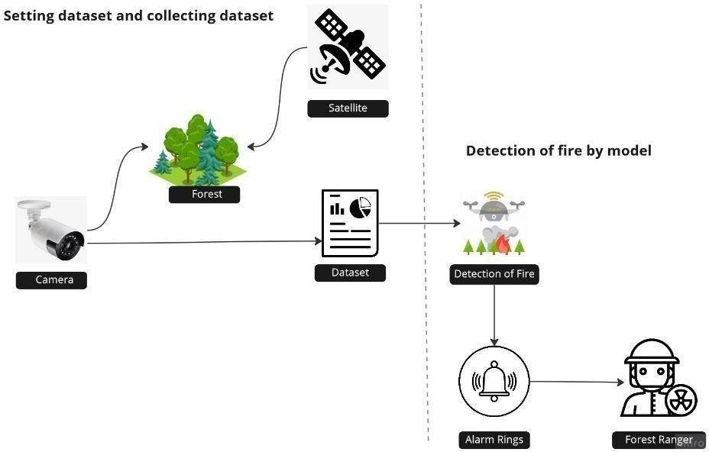

* 1. **SOLUTION & TECHNICAL ARCHITECTURE**

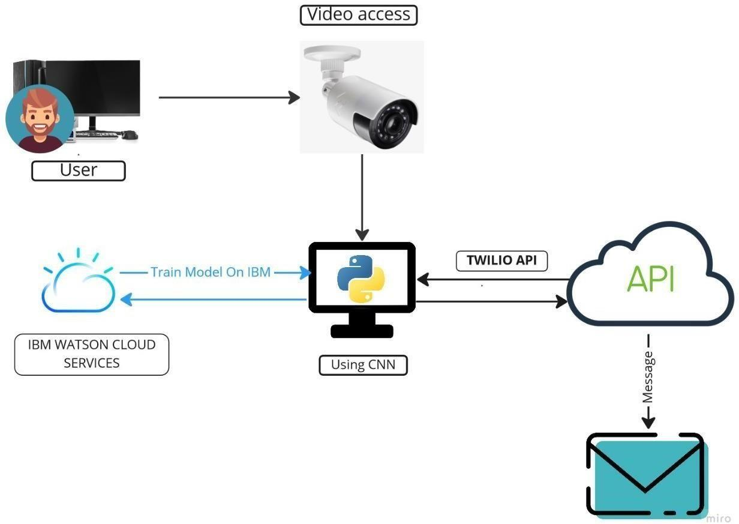

* 1. **USER STORIES**

| **User Type** | **Functional**  **Requirement (Epic)** | **User**  **Story Number** | **User Story / Task** | **Acceptance criteria** | **Priority** | **Release** |
| --- | --- | --- | --- | --- | --- | --- |
| Forest Management Team | Setting up a camera | USN-1 | As a user, the forest management team has to survey the forest by adding camera to the fire prone  areas. | The live video captured can be monitored | High | Sprint-1 |
|  |  | USN-2 | As a user, the forest management team can get video feed which is used for  processing | The camera sends video or image to the forest centre | High | Sprint-2 |
|  |  | USN-3 | Along with forest team, the NGO can also get access of the video to take some early measurement of  forest fires. | They can also get the view of the live monitoring of forest | Low | Sprint-1 |
| Technical Team | Image Classification | USN-4 | By using CNN Model, the images captured by the camera is classified accordingly by testing & training  the model | The model should be able to identify the difference between fire and a normal smoke | Medium | Sprint-2 |
|  | Using Open CV | USN-5 | The recorded video is under monitoring continuously to determine the detection of early  video | Therefore, by using CNN we can determine the input layer, classify the hidden layers and send warnings through  output layer | High | Sprint-2 |
| Alert Team | Dashboard | USN-6 | Thus, after successful detection of fire by processing images. This, API sends the alert by buzzing the alarm and sends messages through  chatbot | Thus, the immediate response which is required for earlier determination through sending quick responses | High | Sprint-2 |
| Fire Management | Twilio API |  | They play the  most important role to cool the | They take the following measures to | High | Sprint-2 |

|  |  |  | fire and manage  the excess spread of fire further | stop fire from spreading |  |  |
| --- | --- | --- | --- | --- | --- | --- |
| **User Type** | **Functional**  **Requirement (Epic)** | **User**  **Story Number** | **User Story / Task** | **Acceptance criteria** | **Priority** | **Release** |
| Media & Nearby Residing  People | News, Radio, Alerts, | USN-7 | Protecting wildlife, human from the disaster  caused | Thus, helping unit should be sent to protect lives | Medium | Sprint-2 |

## CHAPTER 6

**PROJECT PLANNING AND SCHEDULING**

### SPRINT PLANNING AND ESTIMATION

| **Sprint** | **Functional Requirement (Epic)** | **User Story Number** | **User Story / Task** | **Story Points** | **Priority** | **Team Members** |
| --- | --- | --- | --- | --- | --- | --- |
| Sprint-1 | Import the Required, Collecting the  Dataset | USN-1 | To analyze the fire prone areas and to set the surveillance camera to collect and observe the region continuously for early detection. | 2 | High | Yashwath P  Parthiban M  Syed Adnaan I  Syed Aakif Z |
| Sprint-2 | Training & Testing of model | USN-2 | The collected data are categorized on the basis of parameters set to identify. To train the model, CNN is used to test repeatedly by storing the datasets in  server. | 1 | High | Yashwath P  Parthiban M  Syed Adnaan I  Syed Aakif Z |
| Sprint-3 | Model Building,  Reviewing the model | USN-3 | The main task is to check that the model is efficient to work in real time. Therefore, smallest of error decoded needed to be corrected to avoid  future lags | 1 | Medium | Yashwath P  Parthiban M  Syed Adnaan I  Syed Aakif Z |
| Sprint-4 | Implementing the model | USN-4 | The model after testing all it’s functionalities is been implemented at forest management offices to get quick  responses from the model. | 2 | High | Yashwath P  Parthiban M  Syed Adnaan I  Syed Aakif Z |
| Sprint-4 | Connecting it with API | USN-5 | The model should connect with API named Twilio, which receives & sends the management with messages. | 2 | High | Yashwath P  Parthiban M  Syed Adnaan I  Syed Aakif Z |

* 1. **SPRINT DELIVERY SCHEDULE**

| **Sprint** | **Total Story Points** | **Duration** | **Sprint Start Date** | **Sprint End Date (Planned)** | **Story Points Completed (as on Planned End Date)** | **Sprint Release Date (Actual)** |
| --- | --- | --- | --- | --- | --- | --- |
| Sprint-1 | 20 | 6 Days | 24 Oct  2022 | 29 Oct 2022 | ‘  20 | 29 Oct 2022 |
| Sprint-2 | 20 | 6 Days | 31 Oct  2022 | 05 Nov 2022 | 15 | 06 Nov 2022 |
| Sprint-3 | 20 | 6 Days | 07 Nov  2022 | 12 Nov 2022 | 10 | 14 Nov 2022 |
| Sprint-4 | 20 | 6 Days | 14 Nov  2022 | 19 Nov 2022 | 5 | \  20 Nov 2022 |

**CHAPTER 7 CODING & SOLUTIONING**

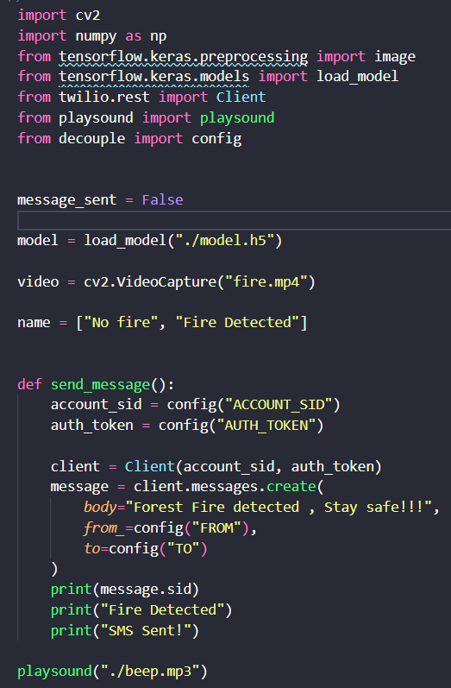

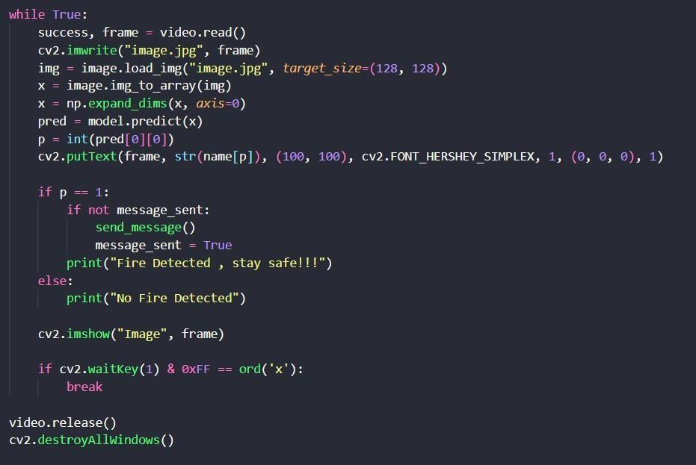

# CHAPTER 8 TESTING

### TEST CASES

| **Test case ID** | **Feature Type** | **Component** | **Test Scenario** | | | **Steps To Execute** | **Test Data** | | **Expected Result** | | **Actual Result** | **Status** | **BUG ID** | **Executed By** |
| --- | --- | --- | --- | --- | --- | --- | --- | --- | --- | --- | --- | --- | --- | --- |
| OP_RT_001 | Functional | Page | Check if user can upload their file | | | The sensor senses the fire | Sample | 1.png | The input image should be uploaded to the application successfully | | Working as expected | PASS | BUG_HP_002 | **Yashwath P**  **Parthiban M**  **Syed Adnaan I**  **Syed Aakif Z** |
| OP_RT_002 | Functional | Page | Check if user cannot upload unsupported files | | | 1. The sensor senses the fire 2. checks with the pre- uploads images | installer.exe | | The application should not  allow user to select a non image file | | User is able to upload any file | FAIL |  |
| OP_RT_003 | Functional | Page | Checks whether the page redirects to the result page to the given output | | | 1) The sensor senses the fire 2)checks with the pre-  uploaded images 3)checks if there is fire  detection | Sample | 1.png | The page should redirect to  the results page | | Working as expected | PASS |  | **Yashwath P**  **Parthiban M**  **Syed Adnaan I**  **Syed Aakif Z** |
| MB_RT_001 | Functional | Backend | Checks if all the routes are working properly | | | 1) The sensor senses the fire 2)checks with the pre-  uploaded images 3)checks if there is fire detection | Sample | 1.png | All the routes should properly work | | Working as expected | PASS |  |
| N_DC_001 | Functional | Model | Checks | whether the can various sizes | model handle image | 1. Open the page in a specific device 2. Upload the input image 3. Repeat the above steps with different input | Sample 1.png Sample 1 XS.png  Sample 1 XL.png | | The model should rescale the  image and predict the results | | Working as expected | PASS |  |
| N_DC_002 | Functional | Model | Check if the model predicts the digit | | | 1. Open the page 2. Select the input images | Sample | 1.png | The model should predict the number | | Working as expected | PASS | BUG_M_001 | **Yashwath P**  **Parthiban M**  **Syed Adnaan I**  **yed Aakif Z** |
| N_DC_003 | Functional | Model | Check if the model can handle  complex input image | | | 1. Open the page 2. Select the input images 3. Check the results | Complex Sample.png | | The model should predict the  number in the compex image | | The model fails to identify the digit since the model is not built to handle such data | FAIL |  |
| RL_DC_001 | Functional | Result Page | Verify the elements | | | 1. Open the page 2. Select the input image 3. Check if all the UI elements are displayed properly | Sample | 1.png | The Result page must be  displayed properly | | Working as expected | PASS | BUG_RP_001 | **Yashwath P**  **Parthiban M**  **Syed Adnaan I**  **Syed Aakif Z** |
| RL_DC_002 | Functional | Result Page | Check if that image is  displayed properly | | | 1. Open the page 2. Select the input image 3. Check if the input image are displayed | Sample | 1.png | The input image should be  displayed properly | | The size of the input image exceeds the display container | FAIL |  |
| RL_DC_003 | Functional | Result Page | Checks whether the  displayed prediction is accurate | | | 1. Open the page 2. Select the input image 3. Check if all the other predictions are displayed | Sample | 1.png | The | other predictions should be displayed properly | Working as expected | PASS |  | **Yashwath P**  **Parthiban M**  **Syed Adnaan I**  **Syed Aakif Z** |

* 1. **USER ACCEPTANCE TESTING**

### DEFECT ANALYSIS

| Resolution | Severity 1 | Severity 2 | Severity 3 | Severity 4 | Total |
| --- | --- | --- | --- | --- | --- |
| By Design | 1 | 1 | 1 | 0 | 3 |
| Duplicate | 0 | 0 | 0 | 0 | 0 |
| External | 0 | 0 | 2 | 0 | 2 |
| Fixed | 3 | 1 | 0 | 1 | 5 |
| Not Reproduced | 0 | 0 | 0 | 1 | 1 |
| Skipped | 1 | 0 | 1 | 0 | 2 |
| Won’t Fix | 1 | 0 | 0 | 0 | 1 |
| Total | 6 | 3 | 4 | 3 | 14 |

* + 1. **TEST CASE ANALYSIS**

| Section | Total Cases | Not Tested | Fail | Pass |
| --- | --- | --- | --- | --- |
| Client Application | 10 | 0 | 2 | 8 |
| Security | 3 | 0 | 2 | 2 |
| Performance | 2 | 0 | 1 | 1 |
| Exception Reporting | 3 | 0 | 0 | 3 |

**CHAPTER 9 RESULTS**

**9.1 PERFORMANCE METRICS**

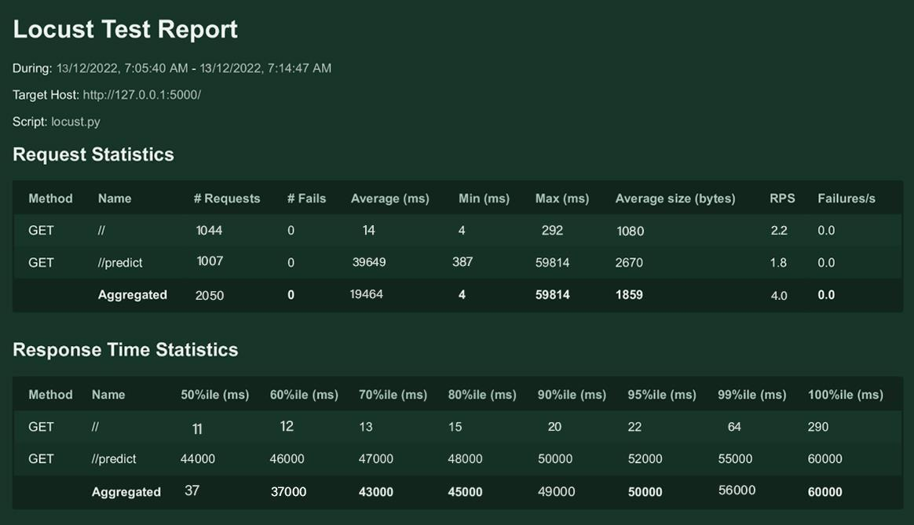

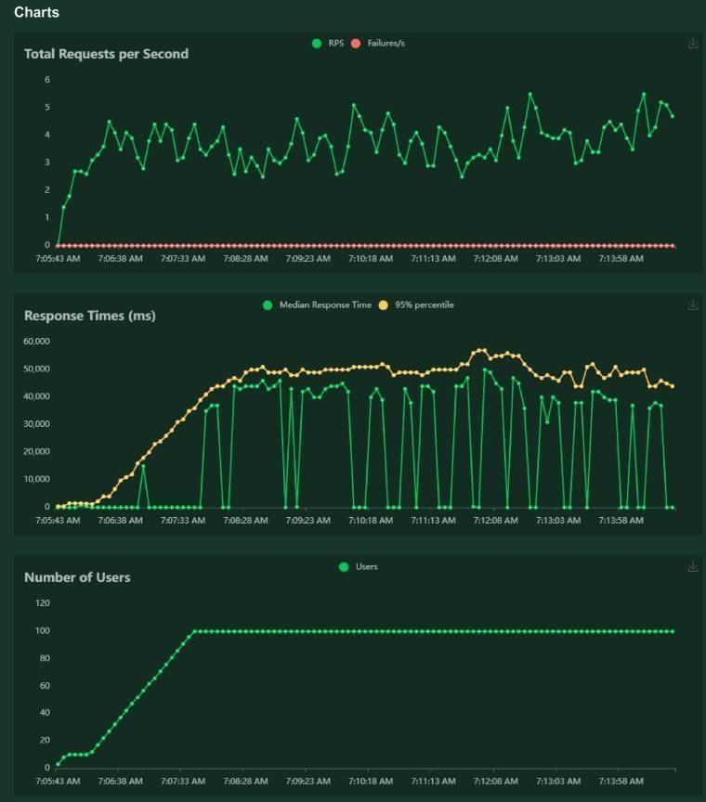

## CHAPTER 10 ADVANTAGES & DISADVANTAGES

### ADVANTAGES

The proposed system detects the forest fire at a faster rate compared to existing system. It has enhanced data collection feature. The major aspect is that it reduces false alarm and also has accuracy due to various sensors present. It minimizes the human effort as it works automatically. This is very affordable due to which can be easily accessed. The main objective of our project is to receive an alert message through an app to the respective user.

### DISADVANTAGES

The electrical interference diminishes the effectiveness of radio receiver.

The main drawback is that it has less coverage range areas.

## CHAPTER 11 CONCLUSION

This type of system is the first of its kind to ensure no further damage is then to forests when there is fire breakout and immediately a message is sent to the user through the App. Immediate response or early warning to a fire breakout is mostly the only ways to avoid losses and environmental, cultural heritage damages to a great extent. Therefore the most important goals in fire surveillance are quick and reliable detection of fire. It is so much easier to suppress fire while it is in its early stages. Information about progress of fire is highly valuable for managing fire during all its stages. Based on this information the firefighting staff can be guided on target to block fire before it reaches cultural heritage sites and to suppress it quickly by utilizing required firefighting equipment and vehicles. With further research and innovation, this project can be implemented in various forest areas so that we can save our forests and maintain great environment.

## CHAPTER 12 FUTURE SCOPE

### This project is far from complete and there is a lot of room for improvement. Some of the improvements that can be made to this project are as follows:

Additional pump can be added so that it automatically sends water when there is a fire breakout. Also industrial sensors can be used for better ranging and accuracy.

🡺 This project has endless potential and can always be enhanced to become better. Implementing this concept in the real world will benefit several industries and reduce the workload on many workers, enhancing overall work efficiency.

# APPENDIX

## SOURCE CODE

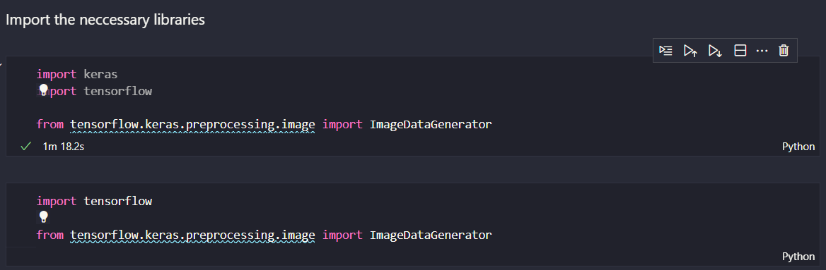

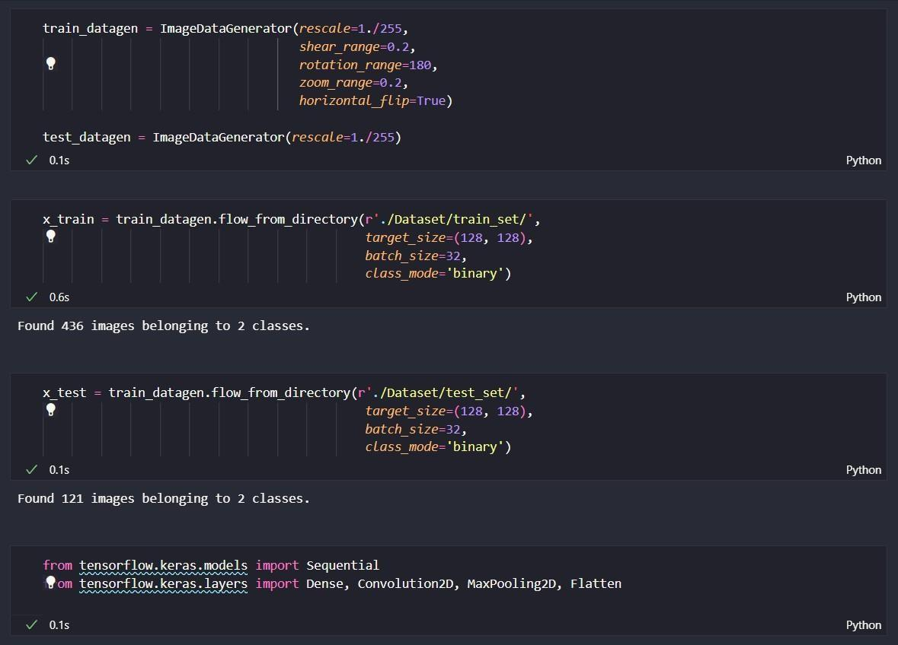

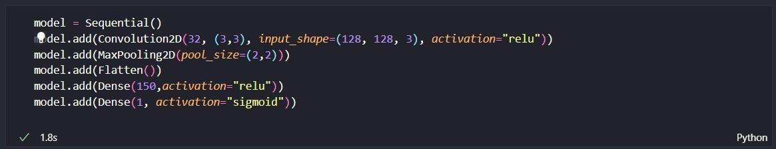

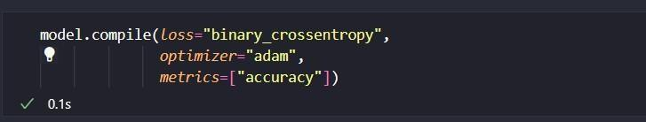

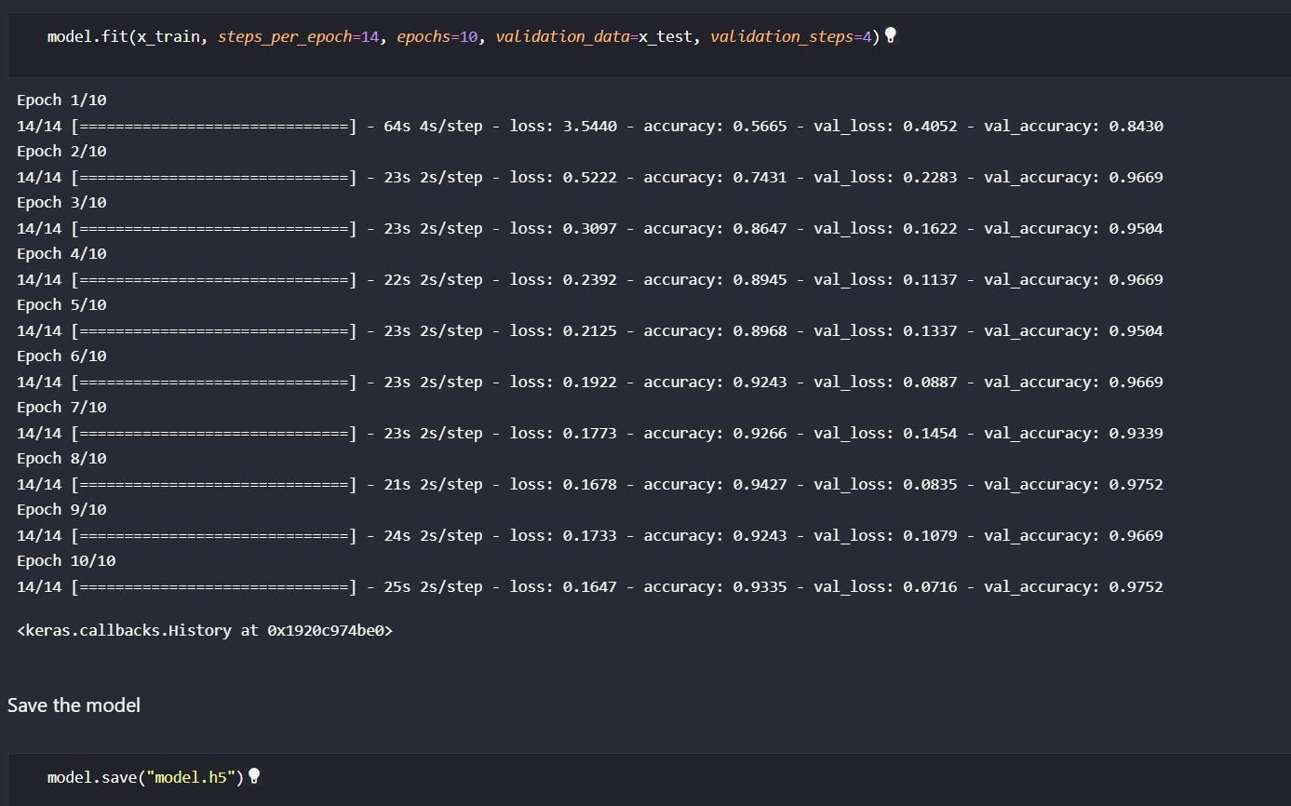

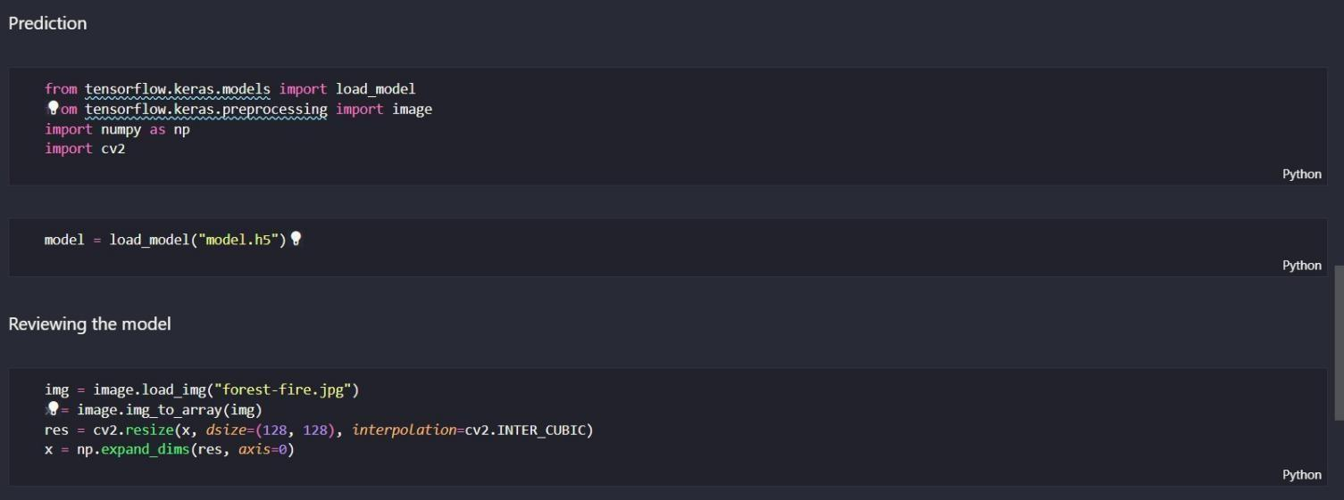

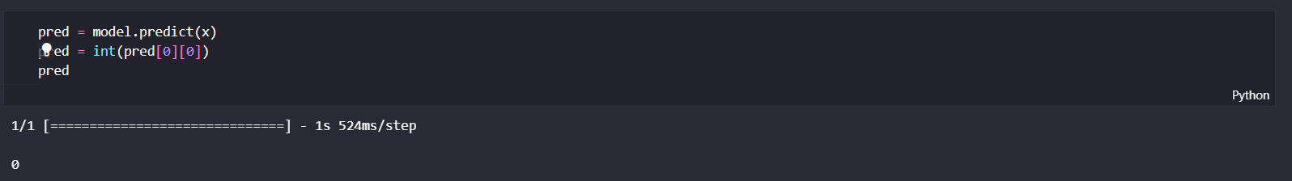

### Fire.py ( Main file )





GITHUB : https://github.com/IBM-EPBL/IBM-Project-29170-1660121813

PROJECT DEMO : https://drive.google.com/file/d/1A_0H6bGRViyAVvm4RNqD7LPfPUNHuFsJ/view?usp=share_link